Practical: 8 | Implementation of Graph and Searching (DFS and BFS).
22/09/2026 | Implementation of Graph and Searching (DFS and BFS).

Aim: To implement of Graph and Searching (DFS and BFS).

Algorithm:

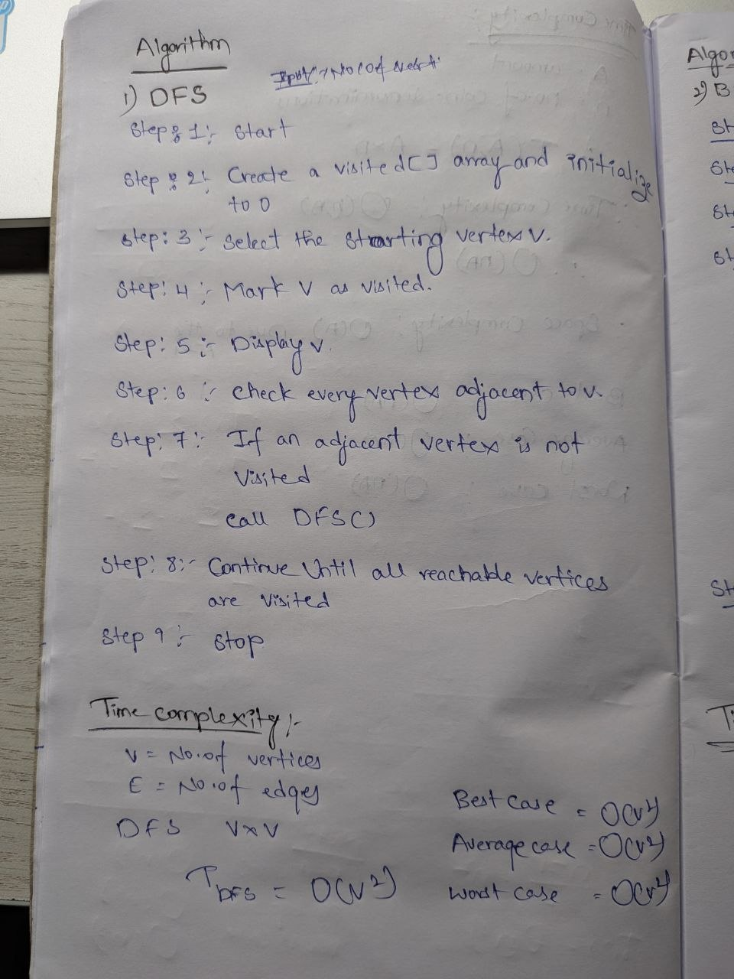

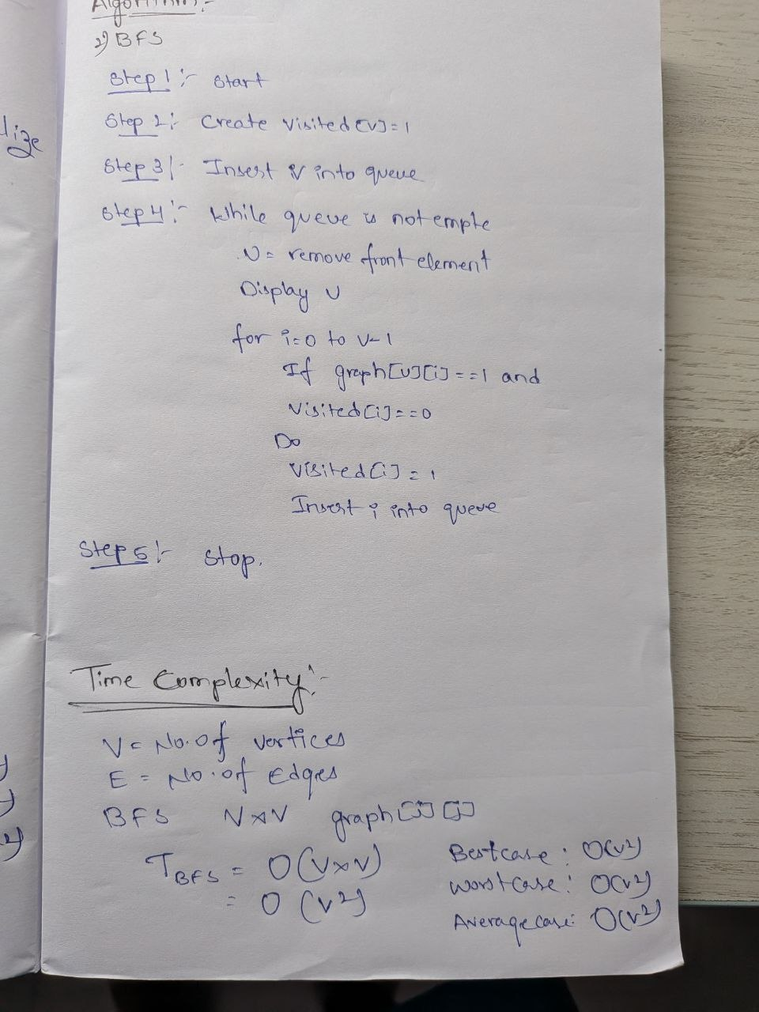

Program:

#include <iostream>
#include <queue>
using namespace std;

int main()
{
// Static adjacency matrix
int graph[5][5] =
{
{0, 1, 1, 0, 0},
{1, 0, 0, 1, 1},
{1, 0, 0, 0, 0},
{0, 1, 0, 0, 0},
{0, 1, 0, 0, 0}
};

int visited[5] = {0};

// ---------- DFS ----------
cout << "DFS Traversal: ";

int stack[5];
int top = -1;

stack[++top] = 0;
visited[0] = 1;

while (top >= 0)
{
int vertex = stack[top--];
cout << vertex << " ";

// Add adjacent vertices
for (int i = 4; i >= 0; i--)
{
if (graph[vertex][i] == 1 && visited[i] == 0)
{
visited[i] = 1;
stack[++top] = i;
}
}
}

// Reset visited array
for (int i = 0; i < 5; i++)
visited[i] = 0;

// ---------- BFS ----------
cout << "\nBFS Traversal: ";

queue<int> q;

q.push(0);
visited[0] = 1;

while (!q.empty())
{
int vertex = q.front();
q.pop();

cout << vertex << " ";

for (int i = 0; i < 5; i++)
{
if (graph[vertex][i] == 1 && visited[i] == 0)
{
visited[i] = 1;
q.push(i);
}
}
}

return 0;
}

Output:

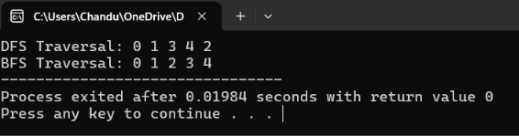

Time Complexity:

Conclusion:
The Implementation of Graph and Searching DFS and BFS are successfully executed with the time complexity of O(V²)
And same for all the three cases of best, average and worst.

